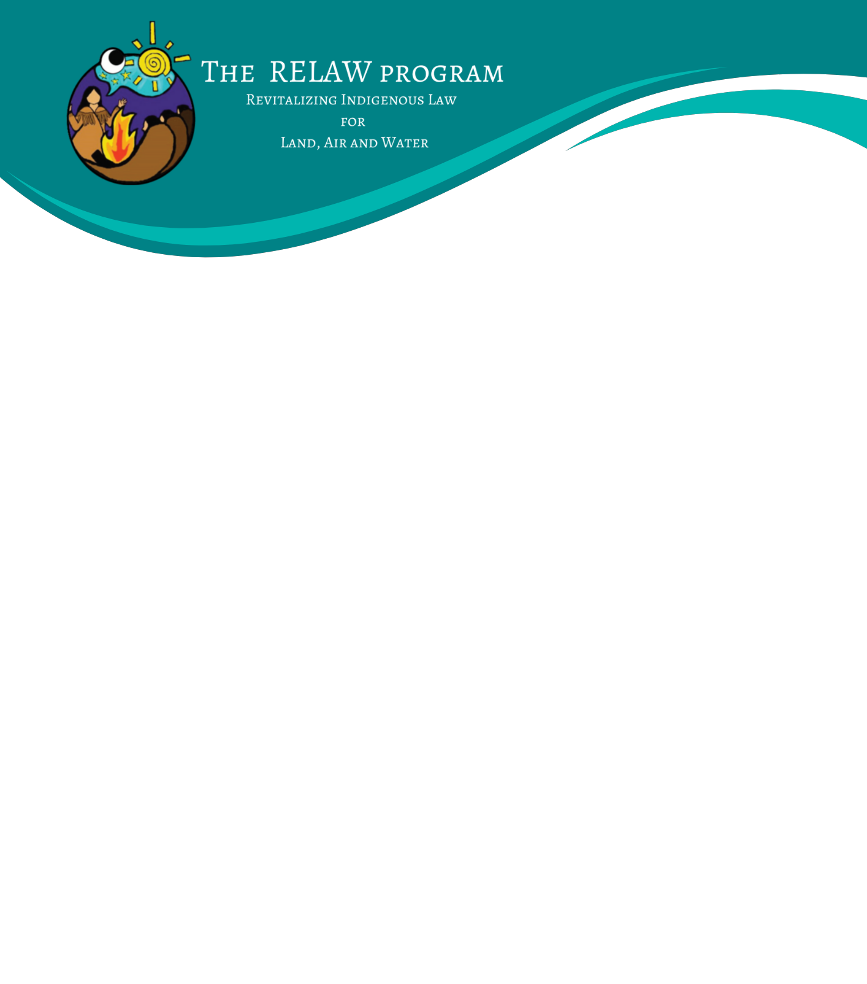

INDIVIDUAL RELAW CO-LEARNERS: EXPRESSION OF INTEREST
We are currently accepting Expressions of Interest to our RELAW Co-learning Program 2022-23 from individuals who wish to learn alongside other like-minded people of approaches and methods of researching, applying and enforcing Indigenous laws. The RELAW Co-learning Program is expected to run from November 2022 - June 2023 with three retreats (2 in-person, 1 online):
- RELAW Retreat 1: Indigenous Law in Story – November 2022 in-person (location TBD)
- RELAW Retreat 2: Indigenous Law in Dialogue – April 4-7 2023 online (Zoom)
- RELAW Retreat 3: Indigenous Law in Action – June 25-29 2023 in-person (location TBD)

For more details see this Co-learning Program Backgrounder.
Or visit: https://www.wcel.org/background-relaw-co-learning-program.

Indigenous nations or organizations may nominate community members, employees or others with an ongoing, close relationship to the community, to participate in the RELAW Co-learning Program.
Expenses covered for the RELAW co-learning retreats include materials, program content, accommodations and meals. Travel to and from the retreat location is the responsibility of the nominating nation or individual co-learner. Stipends may be available to assist with travel costs if your nation is not able to cover this cost.
To apply, please complete the form below and submit to Rayanna Seymour-Hourie, RELAW Manager at rseymour@wcel.org. Space is limited and first consideration will be given to applications received by September 16, 2022.

Name:
Your nation, if known:
Position & Contact information (email and phone):

- Please tell us why you’re interested in participating in the RELAW co-learning program and how your participation will help contribute to revitalization of Indigenous law for your nation (approximately one page).

- Please describe themes or topics you are most interested in learning about, if any.

__________________________________________________________
Applicant signature

Reference name from your Nation/the Nation you are working with to confirm nomination:

________________________________________ __________________________________________
Name Role/Relationship

________________________________________ __________________________________________
Phone Number Email

*We will reach out to them by email and/or phone in mid-September 2022*
If you are interested in participating and it is not possible for your nation to nominate you, please offer a brief explanation.

If you have any questions, please contact:
Rayanna Seymour-Hourie, Staff Lawyer & RELAW Manager at rseymour@wcel.org

